Adaptive Noise Reduction Filter
1) Introduction and Motivation
The fundamental way that noise cancelation works is this:
- Real sound, (e.g. voice/music etc) will have a high autocorrelation because the amplitude of one sound point is conditionally dependent on another
- White noise (e.g. caused by thermal variations) will have a low autocorrelation because the amplitude of one sound point is does not dependent on another

Reference: http://focus.ti.com/lit/an/spra657/spra657.pdf

Autocorrelation is a measure of whether or not a signal has the same shape as a time-shifted version of itself. Signals with regular patterns will have a high autocorrelation and signals with random patterns will have low autocorrelations. This noise cancelation will not remove EM field noise because EM noise is not random.
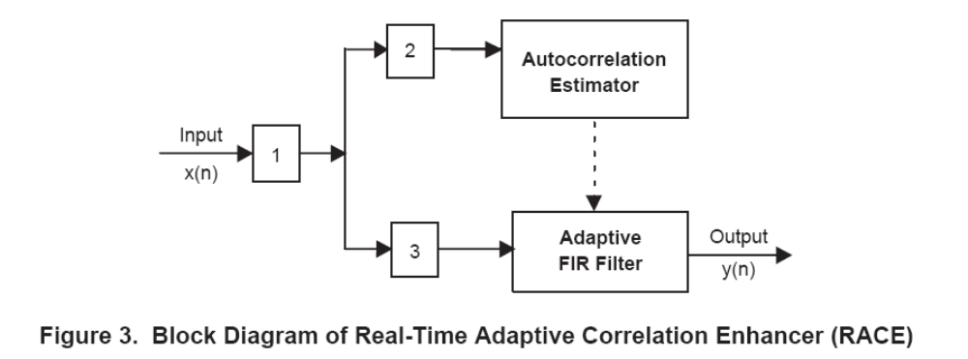
y(n)
z(n)
y(n)
xxxx
R0, R1, R2…
I implemented the “1” position. I tested it with both the electret and dynamic microphones. I used Picoscope to create the equivalent 12-bit ADC and a sampling rate about 12.2 kHz

2) Frequency shaping
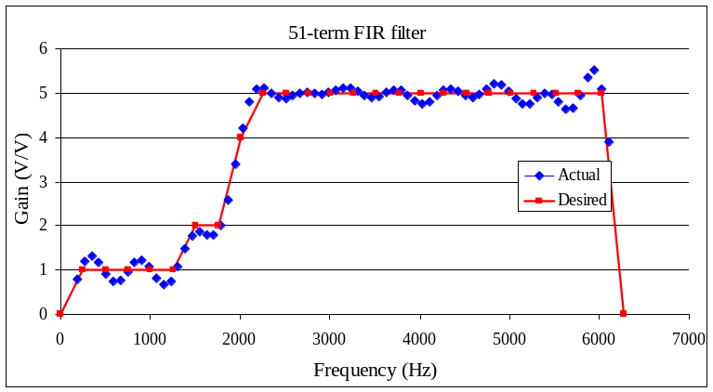
We will use the same 51-term frequency shaping FIR filter with linear phase as before. It will be necessary in this adaptive filter to set the DC gain to zero. This will make the average signal equal to zero. To implement the autocorrelation, it is very important to have a DC gain of zero. I added up all 51 coefficients to make sure their sum was zero, not close to zero, but exactly zero. I had to jiggle some of the gains, so the sum of the filter coefficients was zero. Here is one example with 1/16 fixed-point resolution.

3) Autocorrelation Estimator
For more information about autocorrelation, see
http://cnx.org/content/m13391/latest/

For signals with a zero mean (created by the 51-term frequency shaping FIR filter), discrete autocorrelation is defined as

R_{xx}(k) = ∑y(n)y(n-k) for all n

However, we are interested in the time varying values of the autocorrelation over the last 4 msec, because the individual components of speech have durations of about 4 msec. We will define a discrete-time windowed autocorrelation as

R_{xx}(n,k) ≈ ∑ y(m)y(m-k) for m ±2msec, k = -L to +L

where n is the time variable (n means now in a real time system), and k is the amount of the time shift. Notice that if y(n) is a real sound, then y(n) and y(n-k) will have similar shapes for some k; for this k R_{xx}(n,k) will be large, because y(n) will be positive when y(n-k) is positive, and y(n) will be negative when y(n-k) is negative.
Let L is a number between 5 and 7, and k goes from –L to +L. Let n_{T} be the number of data samples in the 4 msec speech epoch. Sampling at 12.8 kHz means n_{T} will be 4ms*12.8kHz or about 51. If L=6, this would require 13*51 (663) additions and multiplies for each sample. To reduce the computational load of the real-time system, the windowed autocorrelation will be approximated by the recurrence relation

R_{xx}(n,k) = βR_{xx}(n-1,k)+(1-β)y(n)y(n-k) for k = -L to +L

where β is a constant. Each relation will require 3 multiplies and 1 addition. This means each sample will require 39 multiples and 13 additions (with L=6.) Notice, I define the above recurrence relation with “-k” where as the TI reference uses +k. Because k goes from –L to +L, I suppose this difference is not important.

Time shift the x input data by L, so all 13 autocorrelations are causal.

R_{xx}(n,k) = βR_{xx}(n-1,k)+(1-β)y(n-L)y(n-k-L) for k = -L to +L

To keep the size of the numbers within 16 bits I scaled the R_{xx}

R_{xx}(n,k) = βR_{xx}(n-1,k)+(1-β)y(n-L)y(n-k-L)/256 for k = -L to +L

I chose the 256 so the various R_{xx} calculations were in the 1000 to 10000 during a speech epoch. I did implement integer math using the truncate to integer function (trunc). I also looked at the R_{xx} calculations to make sure the size of the numbers remained less than 10000.

When we implement the recurrence relations, we will not need a separate memory for R_{xx}(n,k) and R_{xx}(n-1,k). We will just read the old value in R_{xx}(n-1,k), perform the function and store the result back into the same variable. Using this time-shifted data, we calculate 2L+1 estimations of the autocorrelations
R_{xx12} = βR_{xx12}+(1-β)y(n-6)y(n-12) / 256
R_{xx11} = βR_{xx11}+(1-β)y(n-6)y(n-11) / 256
R_{xx10} = βR_{xx10}+(1-β)y(n-6)y(n-10) / 256
R_{xx9} = βR_{xx9}+(1-β)y(n-6)y(n-9) / 256
R_{xx8} = βR_{xx8}+(1-β)y(n-6)y(n-8) / 256
R_{xx7} = βR_{xx7}+(1-β)y(n-6)y(n-7) / 256
R_{xx6} = βR_{xx6}+(1-β)y(n-6)y(n-6) / 256
R_{xx5} = βR_{xx5}+(1-β)y(n-6)y(n-5) / 256
R_{xx4} = βR_{xx4}+(1-β)y(n-6)y(n-4) / 256
R_{xx3} = βR_{xx3}+(1-β)y(n-6)y(n-3) / 256
R_{xx2} = βR_{xx2}+(1-β)y(n-6)y(n-2) / 256
R_{xx1} = βR_{xx1}+(1-β)y(n-6)y(n-1) / 256
R_{xx0} = βR_{xx0}+(1-β)y(n-6)y(n) / 256

In order to choose β, we will consider this simple IIR filter

y(n) = β y(n-1)+ (1- β)x(n)

The transfer function of this simple IIR filter is
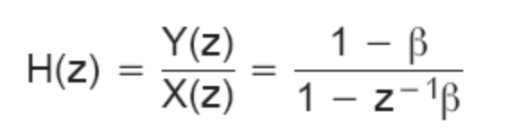

To set the window length at n_{T} =51 samples, we use the relation between β and n_{T}.
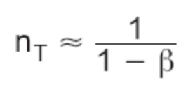 1/n_{T} = 1-β β = 1-1/n_{T} = 0.98

I tried lots of values for β (without being to “hear” any difference; they all looked the same in the graphs).
β n_{T} epoch (ms)
0.99 100 8.2
0.98 50 4.1
31/32 32 2.5
0.9 10 0.8

4) Adaptive FIR (nonlinear filter)
After estimating the autocorrelations, we use them as filter taps (coefficients) for a FIR filter with sequence length 2L+1.

z(n) = (R_{xx0} y(n)+ R_{xx1} y(n-1)+ R_{xx2} y(n-2)+ R_{xx3} y(n-3)+ R_{xx4} y(n-4)
+ R_{xx5} y(n-5)+ R_{xx6} y(n-6) + R_{xx7} y(n-7)+ R_{xx8} y(n-8)+ R_{xx9} y(n-9)
+ R_{xx10} y(n-10)+ R_{xx11} y(n-11)+ R_{xx12} y(n-12))/16384

where the 16384 was chosen to make the data pretty. As written the 13-term accumulated sum will be over 16 bits. y(n) are -2000 to +2000, and R_{xx} are -10000 to +10000. However, on the MSP430 this will be implemented with a fractional multiply. I.e., consider the R_{xx}/16384 as a signed binary fraction with values from -1 to +1.

If the signal is noisy, then all the R’s will be small, creating a low-gain FIR. If the signal is real sound, then some of the R’s will be large creating a high-gain FIR.

5) Results
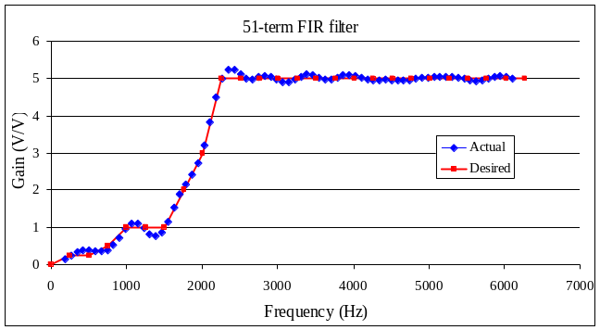
I giggled the gains until the sum of the filter coefficients was exactly 0. The coefficients were -1, 0, 1, 1, 0, -1, -1, -1, 0, 0, 0, -1, 0, 1, 2, 1, -2, -4, -2, 2, 6, 4, -6, -22, -36, 118, -36, -22, -6, 4, 6, 2, -2, -4, -2, 1, 2, 1, 0, -1, 0, 0, 0, -1, -1, -1, 0, 1, 1, 0, -1

k | f (Hz) | Mag(X(k))
0 | 0.00 | 0.00
1 | 250.98 | 0.25
2 | 501.96 | 0.25
3 | 752.94 | 0.50
4 | 1003.92 | 1.00
5 | 1254.90 | 1.00
6 | 1505.88 | 1.00
7 | 1756.86 | 2.00
8 | 2007.84 | 3.00
9 | 2258.82 | 5.00
10 | 2509.80 | 5.00
11 | 2760.78 | 5.00
12 | 3011.76 | 5.00
13 | 3262.75 | 5.00
14 | 3513.73 | 5.00
15 | 3764.71 | 5.00
16 | 4015.69 | 5.00
17 | 4266.67 | 5.00
18 | 4517.65 | 5.00
19 | 4768.63 | 5.00
20 | 5019.61 | 5.00
21 | 5270.59 | 5.00
22 | 5521.57 | 5.00
23 | 5772.55 | 5.00
24 | 6023.53 | 5.00
25 | 6274.51 | 5.00

I used the both the WM54B4 electret and the dynamic microphone. I captured noise and speech sounds with the Picoscope in AC mode, 50 ms/division resulting in a sampling rate of about 12.2 kHz. The first two are just noise

5.1. 12-bitADC, electret WM54B4 (noise1.xls, noise2.xls, hello.xls, clock.xls
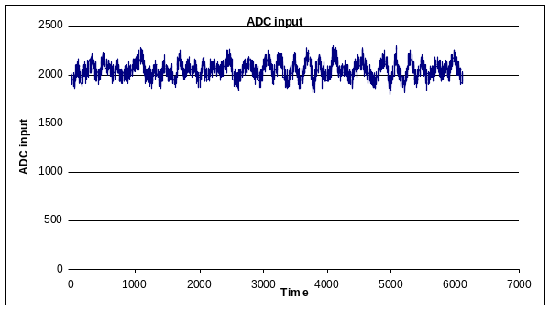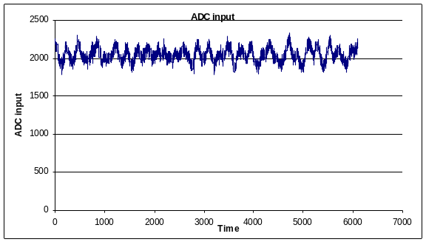
Noise, raw input with electret microphone, x(n)

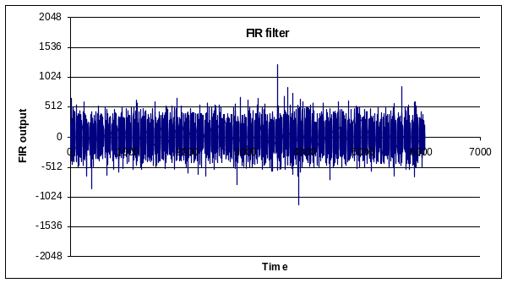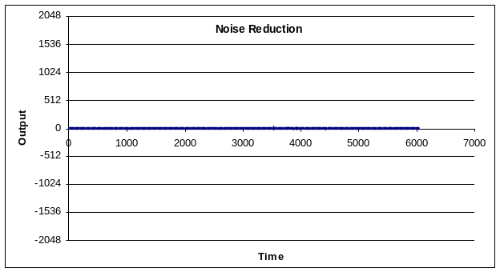
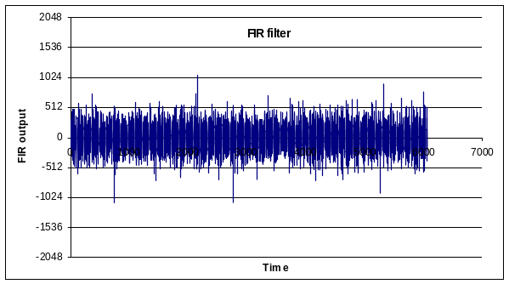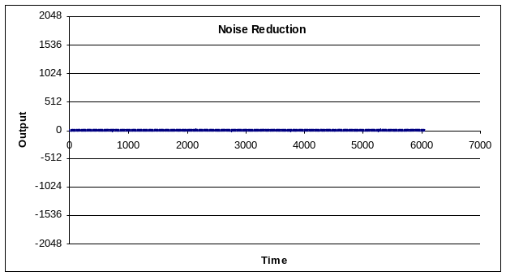
Noise, after FIR filter, y(n) and adaptive noise rejection, z(n)

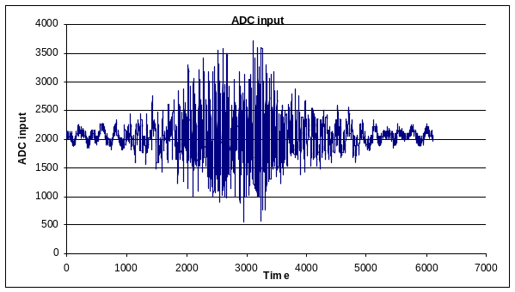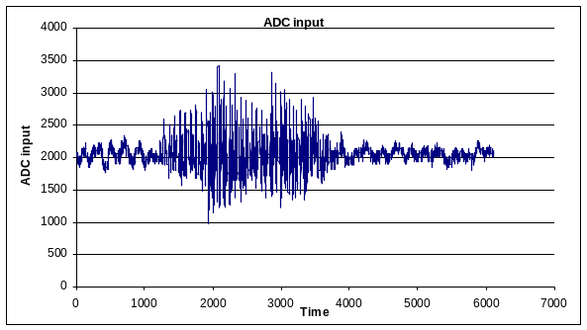
Spoken word “Hello”, x(n) Spoken word “Clock”, x(n)

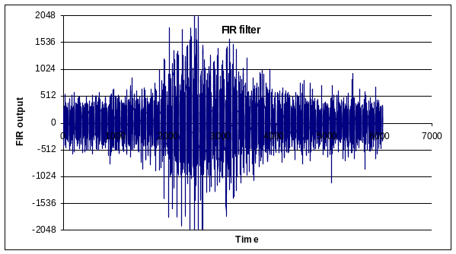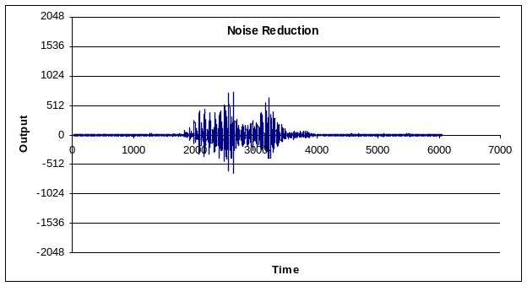
Hello sound, after FIR filter, y(n) and adaptive noise rejection, z(n)

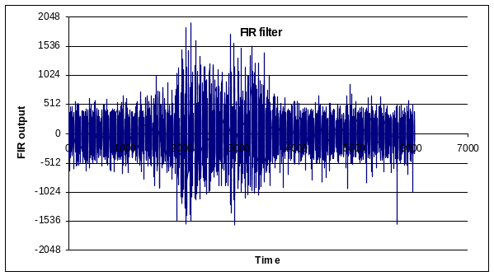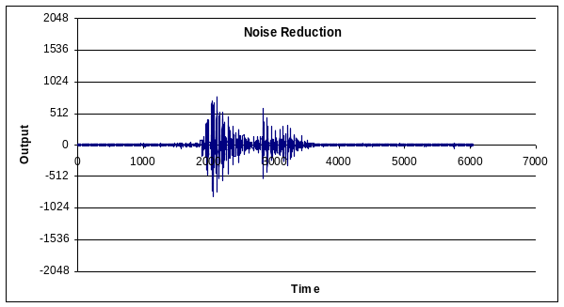
Clock sound, after FIR filter, y(n) and adaptive noise rejection, z(n)

5.2. 12-bitADC, dynamic microphone (noise3.xls, noise4.xls, hello3.xls, clock3.xls
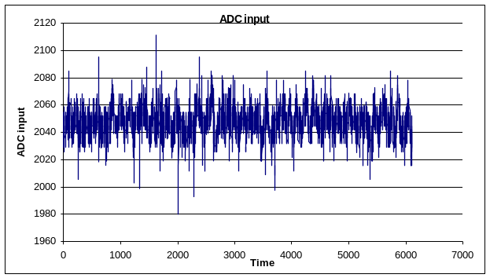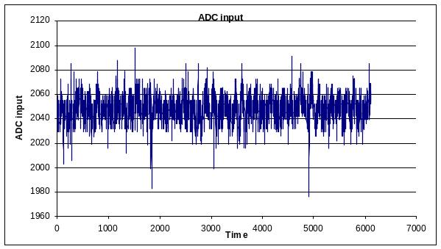
Noise, raw input with dynamic microphone, x(n)

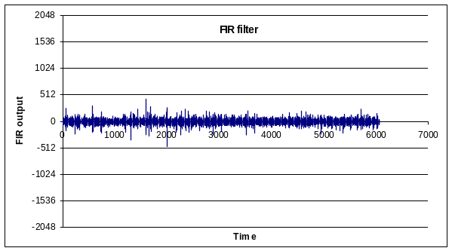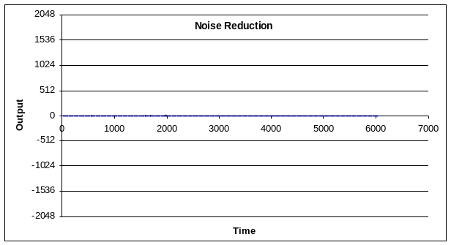
Noise, after FIR filter, y(n) and adaptive noise rejection, z(n)

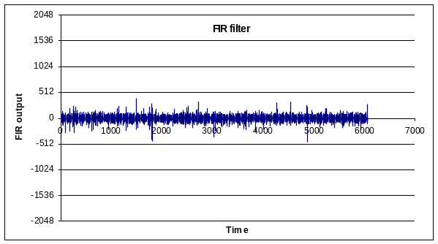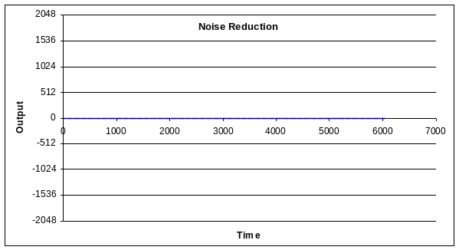
Noise, after FIR filter, y(n) and adaptive noise rejection, z(n)

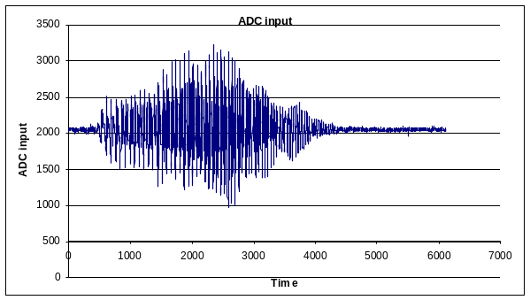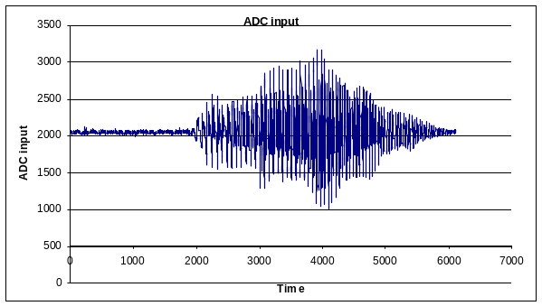
Spoken word “Hello”, x(n) Spoken word “Hello”, x(n)

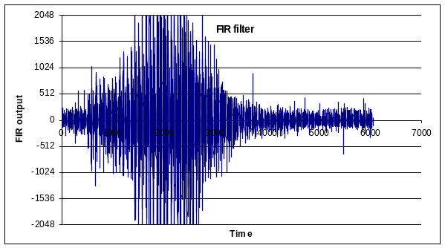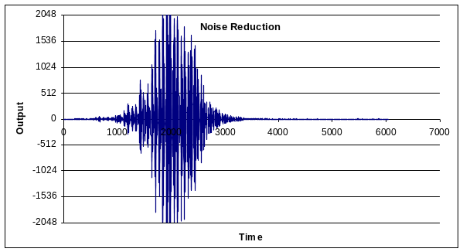

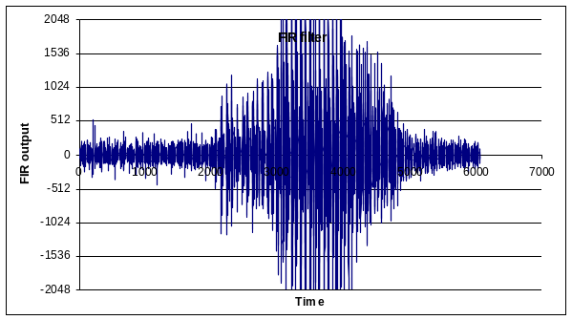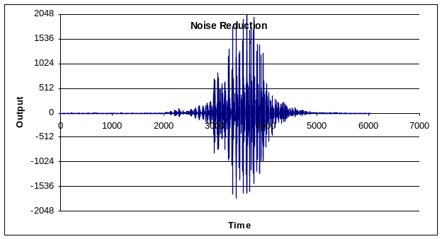
Hello, after FIR filter, y(n) and adaptive noise rejection, z(n)

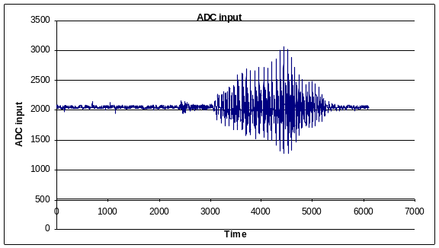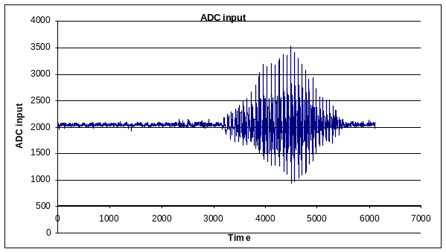
Spoken word “Clock”, x(n) Spoken word “Clock”, x(n)

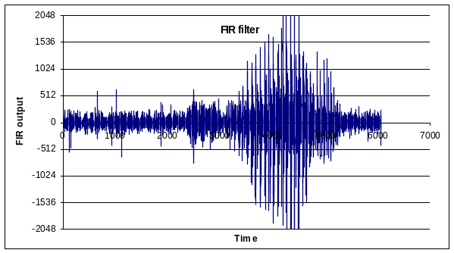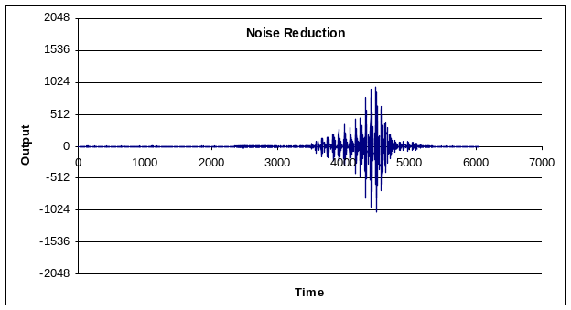
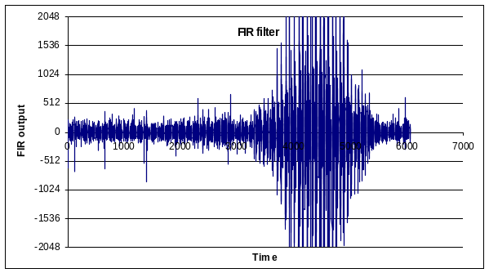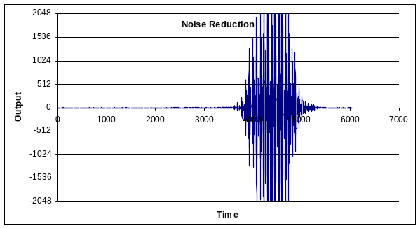
Clock, after FIR filter, y(n) and adaptive noise rejection, z(n)

6) MSP430 implementation
6.1 Simplifying the approach of sections 3 and 4
There are no multiplication or no division instructions on the MSP430. To reduce computational load, I tried a couple of things. First of all, the MSP430T2012 has a 10-bit ADC. Next, I reduced L, so there are three (instead of 13) estimations of R_{xx}. x(n) is the 10-bit ADC input, sampled at 12.8 kHz, and y(n) is the output of the 51-term FIR filter. Because of the large gain at high frequencies, y(n) is signed 11 or 12 bits. If y(n) is 12 bits, then y(n)*y(n) is 24 bits and too big for the MSP430. So, I reduced the 12-bit y(n) to 7 bits by shifting right before multiplying. I.e., y(n)/32 is only 7 bits wide. To simplify the β multiplication, I set β to be 31/32 (about 0.97). The R_{xx6} is more of a power estimation and not an autocorrelation (y(n)*y(n) is always positive), so even though R_{xx6} was largest, I skipped R_{xx6} in favor of the smaller amplitude R_{xx7} R_{xx8} and R_{xx9} terms because these better embody the concept of using autocorrelation to separate noise from signal. Since R_{xx5} is similar in amplitude to R_{xx7} and R_{xx4} is similar in amplitude to R_{xx8}, I used just R_{xx7} R_{xx8} and R_{xx9} rather than R_{xx3} R_{xx4} R_{xx5} R_{xx7} R_{xx8} and R_{xx9}.

R_{xx9} = (31R_{xx9} + (y(n-6)/32)(y(n-9)/32)/32
R_{xx8} = (31R_{xx8} + (y(n-6)/32)(y(n-8)/32)/32
R_{xx7} = (31R_{xx7} + (y(n-6)/32)(y(n-7)/32)/32

z(n) = ( R_{xx7} y(n-7) + R_{xx8} y(n-8) + R_{xx9} y(n-9) )/32
s(n) = R_{xx7} + R_{xx8} + R_{xx9}

6.2 MSP Implementation
Next, we renumber the samples to reduce storage. Again, let y(n) be the output of the FIR filter. Therefore, y(n-1) is the previous output of the FIR filter, and y(n-2) is the output of the FIR filter two samples ago. We will clip the values of y(n) to fit into 12 bits (-2048 to +2047). We will calculate y(n)/32 once and store this and the previous 3 calculations in a buffer. t0 t1 t2 and t3 will be 8-bit signed memory variables, but we expect the data to be 7-bit signed numbers. There are five adjustment “knobs” on this filter. The first “knob” is the number of autocorrelation terms. I implemented three terms because of RAM memory limitations. The second “knob” is the 32 in the t0=y0/32 equation. Experimentation shows Rxx1 Rxx2 and Rxx3 go to zero on silence and nonzero for spoken words.

y3 = y2; // y(n-3)
y2 = y1; // y(n-2)
y1 = y0; // y(n-1)
y0 = 51-term FIR filter output

t3 = t2; // y(n-3)/32
t2 = t1; // y(n-2)/32
t1 = t0; // y(n-1)/32
t0 = y0/32; // y(n)/32

Rxx1 Rxx2 and Rxx3 are 16-bit signed memory variables, but we will clip the values to fit in 6 bits (-16 to +15). Rxx1 Rxx2 and Rxx3 are the equivalent of R_{xx7} R_{xx8} and R_{xx9}. The third “knob” is the β = 31/32.

Rxx1 = (31•Rxx1 + t0*t1)/32
if(Rxx1 < -16) Rxx1 = -16;
if(Rxx1 > 15) Rxx1 = 15;

Rxx2 = (31•Rxx2 + t0*t2)/32
if(Rxx2 < -16) Rxx2 = -16;
if(Rxx2 > 15) Rxx2 = 15;

Rxx3 = (31•Rxx3 + t0*t3)/32
if(Rxx3 < -16) Rxx3 = -16;
if(Rxx3 > 15) Rxx3 = 15;

where this * is an 8-bit by 8-bit signed multiply into 16-bit signed product. The above three /32 functions implement an integer truncation towards zero (e.g., 63/32 goes to 1, and -63/32 goes to -1). I clipped the Rxx terms so they fit in the range of -16 to +15. The fourth “knob” is the -16 to +15 clipping range for the terms Rxx1 Rxx2 and Rxx3. This clipping reduced the overflows on the output. The autocorrelation terms are used as filter taps. The fifth “knob” is 32 gain term in the following.

z(n) = Rxx1*y1/32 + Rxx2*y2/32 + Rxx3*y3/32

where this */ is a 8-bit by 12-bit fractional signed multiply into 16-bit signed product. In other words, the Rxx*y/32 will be performed in one function. z(n) is output to the DAC. It seems to me that if the signal contains speech, then all terms will be high and the above filter implements a three-wide averaging filter.

6.3. MSP430 Measurements
I captured noise and speech sounds with the Picoscope in AC mode, 50 ms/division resulting in a sampling rate of about 12.2 kHz. The input and output are captured with the same conditions and settings, but at different times (Picoscope is a single channel device). The output has a crackle occurring with each DAC output, seen also on the 3.7 supply and 1.25V reference.

